## SPOTER

## Satellite based Vehicle Tracking System

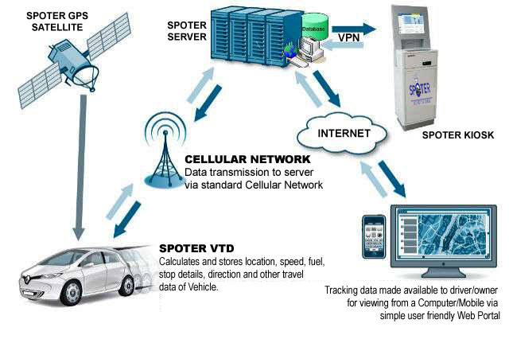

Dear,

Thank you for showing interest and allowing us a opportunity to introduce you to SPOTER - A Satellite based Vehicle and Fleet Management System and Solution.

Spoter is a comprehensive device, which helps a owner to Track, Monitor, Safe-guard, Control and Manage a vehicle, driver, Goods and Fleet through a single web interface.

Due to its low-cost and effective management, it make easy to process and monitor operations for fleet owners like Logistic, Transport, Education, Rental Service operators, corporate companies, Hospitals, Security Services, Government and many other types of Organisations and Agencies.

The essence of telemetry and use of location based services (LBS) is to enhance security, efficiency and reduce operation cost.  In addition, it also enhances effective monitoring and control of personnel and assets.

Spoter is an advanced Vehicle Monitoring System with advanced management capabilities that offers much more features than a standard GPS Tracking system at comparable, or in most cases lower cost. The system is backed by technicians and engineers with the ability to customize expand and successfully deploy it to virtually any application. Our System, tracks current location and speed by 24 Satellites which assures the owner of best and quality services as compared to other similar looking products in Market.

*The features included in our Basic model for customers are as follows’.*

1)      High sensitivity GPS chip-set.  
2)      Built–in switching power supply, wide voltage input: 9V to 24V.  
3)      Optional SMS functionality supported.  
4)      Built-in monitoring CPU, automatic fault recovery.  
5)      Support GSM 900/1800MHz cellular network as data carrier.  
6)      Built-in GSM and GSM Antenna.  
7)      Built-in Storage Capacity.  
8)      Optional Wire-tapping (Voice monitoring) - Optional.  
9)      Inbuilt motion sensor for power saving and exact location identification.  
10)    SOS panic button - Emergency Purpose.  
11)    Geo- fencing control.  
12)    Low battery alarm.  
13)    Over speeding alarm.  
14)    Portable, easy to install.  
15)    Can be used as Parent tracker, Pet tracker, Asset tracker, Child tracker.  
16)    Real Time System View (Track a wide range of vehicles at a time).  
17)    On board data storage (The tracking information of 30 days of vehicle stored automatically.)  
18    Advanced Reverse Geo-coding based on accurate google map data (accurate street names for stops)  
19)     Flexible Reporting Platform (Time on customer site, over idle, service / odo-meter, stop with distance travelled, geofence reports, etc.)  
20)    Mobile interface (View vehicle locations from a mobile device)  
21)    Anti-theft protection.  
22)    One year Standard warrantee.

**BENEFITS**

* **Internet Tracking:** we offer real-time tracking, i.e. you have complete control of your vehicles by monitoring its activities on-line.
* With the **enable/disable** facilities, Theft and Misuse of automobiles and other assets will be reduced.
* With its effective work distribution and monitoring, staff productivity will be enhanced.
* Reduce cost with fuel sensor to monitor fuel loading and usage.
* Safe-guards vehicles by monitoring maintenance, as well as on time information during accident or theft.
* Customized reports for various departments e.g. Admin/Finance etc.
* Accident dispute can be managed better by monitoring speed and driving habit of the driver.
* **Speed:** it has a perfect fast speed in operation between user and vehicle.
* Uses SMS and Internet for presenting reports.
* **SMS alert:** receive additional SMS for specified events on your vehicle.

The solutions we offer provide visibility of your vehicle anywhere in India we also have significant technical advantages over other competing products in the market today. These solutions allow you to:

* Increase safety of vehicles and occupants
* Reduce operating cost
* Have control of your vehicles
* Reduce risk of theft to the barest minimum.
* Increase productivity.

**Commercial Pricing Proposal –** Vehicle Tracking Solution

|  |  |
| --- | --- |
| **Product Description** | **Price in INR [Per Unit]** |
| Standard tracking device LS02M2100 (per vehicle/per unit) | **5,400.00/-** |
| Streaming Server Subscription  (per-vehicle/per-unit)  **Annual (Payable in Advance)**  (Including Reports, Web control panel, web space) | **3,600.00/-** |
| Storage Subscription Charges  (per-vehicle /per-unit)  **Annual (Payable in Advance)**  (Including Data Backup & Storage) | **1200.00/-** |
| Data Subscription Charges with national roaming fees.  (per-vehicle/per-unit)  **Annual (Payable in Advance)**  (Including Activated SIM, GPRS) | **1800.00/-** |
| Installation (Per Vehicle / One Time) | **3000.00/-** |

* Taxes applicable extra as applicable.

**Terms & Conditions:**

**Warranty**

1 year repair/replacement standard limited warranty on the Tracking Device.

**Annual Maintenance Cost Rs. 2000/-**

To extend the comprehensive warranty you will need to cover them under an AMC.

*AMC will cover:*

* *Unit replacement in case of damage one time maximum for four times.*
* *4 preventive service calls per unit yearly*
* *4 trouble-shooting calls per unit yearly*

**Terms and Liabilities**

**A. Payment:** 100% advance against purchase order.

**B. Delivery:** Delivery within 2-3 Weeks of receipt of purchase order and advance payment.

**Carry – In Warranty**

Spoter warrants that in normal usage and with proper maintenance, its product (Vehicle Tracking Unit) will conform to their specification for a period of 12 months from the date of purchase by the customer, subject to the conditions, limitations and procedure listed below. Any product, which proves to be defective in normal usage during that 12 months period, will be repaired at Spoter or replace by Spoter. Warranty does not cover any battery, pad, Antennas & cables.

**Limitations**

Spoter shall be limited to the repair or replacement of any parts of the product, which are defective in materials.

Spoter Shall not be liable in any way for Product failure, or any resulting loss or damage which arises from:

* Use of product in an application for which it was not designed or intended.
* Corrosion, degradation or wear and tear.
* Failure to service or maintain the product in accordance with Spoter recommendations.
* Faulty or deficient installation of the product.
* Any modification of alteration of the product.
* Conditions that exceed the products performance specifications or safe working loads.
* This warranty does not cover any incidental costs incurred for the investigation, removal, carriage, transport or installation of product.
* Service by anyone other than authorized Spoter representatives shall be taken as warranty void unless it accords with Spoter guidelines and standards of workmanship.

**Liability**

*Spoter shall not be responsible for*

* Any loss of anticipated turnover or profit or indirect, consequential or economic loss.
* Damages, costs or expenses payable to any third party.
* Death or personal injury.
* Any loss of warranty of vehicle due to installation of device.

**Procedure**

* Both warranty and non-warranty repairs can only be performed at Spoter.
* The customer shall send the goods together with an order for warranty or non-warranty repair to the Spoter service office. The order shall be delivered in writing by mail or electronic mail.
* The order must contain a detailed description of the defect.
* Both warranty and Non-warranty repairs shall be carried out by Spoter in 25-30 working days from the receipt of order.
* In case of warranty repair, the customer shall be responsible for transport of goods to service office and transport of goods back to the customer. If it is found that the repair is not subject to warranty, all costs of repairs will be borne by the customer.

**Service Level Details**

* In case of any manufacturing defect in the Tracking Unit or need for any trouble-shooting in the Tracking software, the support team will respond to addressed problem within 6 hours provided the vehicle is made available for check at mutually agreed location.
* For the location other than mutually agreed location, the service engineer will assess the cause of problem and will provide the time and assistance to repair, on case basis. The response of support service will be in addition to the travel time to provide the response.

**Validity of Proposal**

The proposal for Vehicle Tracking Solution will be valid for duration of 7 days from the date of submission.

**Promotion:**

If any association/ Organization achieve 100 Device billing at a time, A Spoter Terminal will provide free-of-Cost to the association / Organization, by which member can track easily with their username and password.

**For demo:** login onto: [www.spoter.in](http://www.spoter.in) - Under ‘Tracking Server 1’.

USERNAME: demo

PASSWORD: demo

**Thanking You…**

We look forward to hearing from you.

**Contact Person** - Taha Shabbir.

**Designation** – Chief Marketing Officer.

**Telephone** - +91 7872766958

**Email** - [sankar@spoter.in](mailto:sankar@spoter.in)

**Website** - [www.spoter.in](http://www.spoter.in)